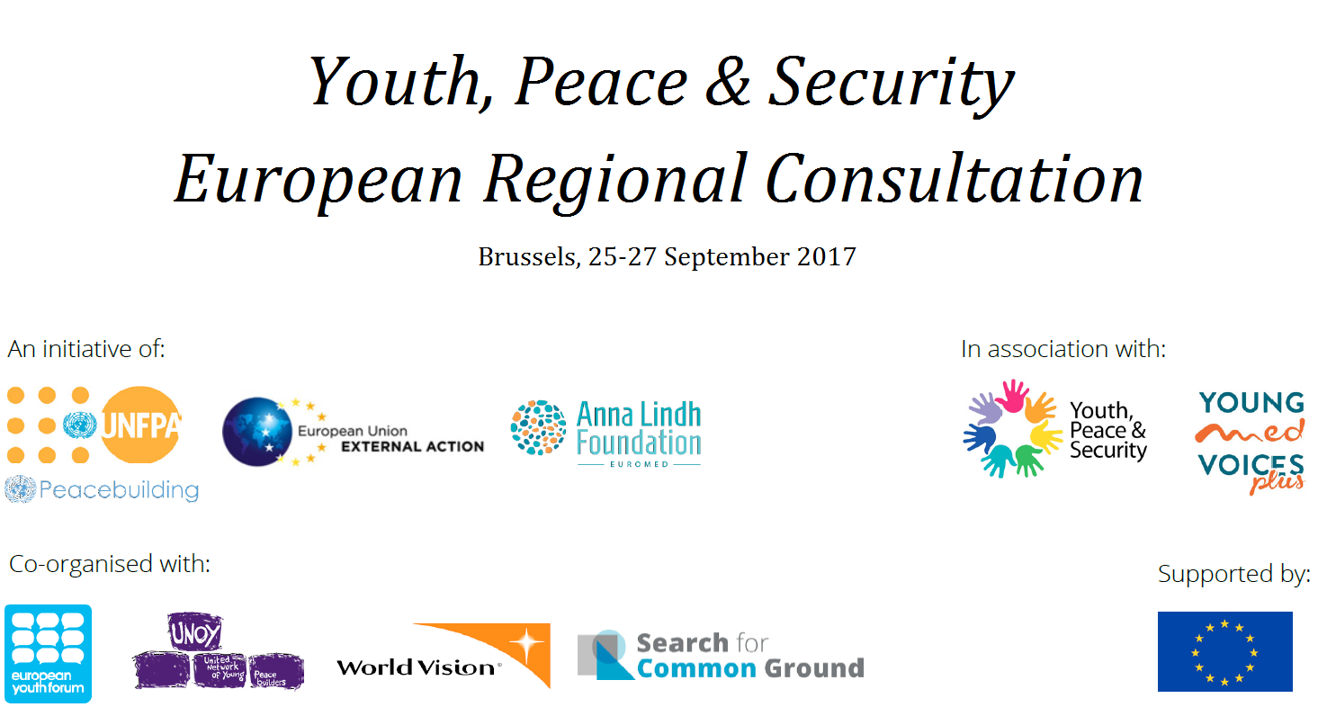

CALL FOR APPLICATIONS: Youth, Peace & Security European Regional Consultation
Calling young people promoting peace and security in Europe!
We are seeking 40 young people between the age of 15 and 29 who are active, enthusiastic and invested in promoting peace and security across the European Union, the countries of the European Free Trade Association and the Western Balkans, to help discuss and orient the role of youth in sustaining peace in their communities and countries.
As part of a series of regional consultations organised within the framework of the progress study on Youth, Peace and Security, mandated by UN Security Council Resolution 2250 (2015), the European External Action Service, in partnership with the United Nations Population Fund, the United Nations Peacebuilding Support Office, the Anna Lindh Foundation, the European Youth Forum and the European Partnership for Children and Youth in Peacebuilding, will organise a European consultation on Youth, Peace and Security. The consultation will take place in Brussels, Belgium from 25 to 27 September 2017, and it will be part of a global effort to bolster action on the UN Security Council Resolution 2250 that calls for a greater role for young people in strengthening peace and security. The discussions from various regional consultations, and other discussions with young people throughout the world, will feed into the progress study highlighting the positive contribution of young people to peacebuilding. The progress study will be presented to the UN Security Council and Member States in early 2018. The European consultation in Brussels will comprise of strategic peer to peer discussions among 40 selected young people from the region.
The selection of participants will be made based on motivation and experience, with the majority coming from youth-led organisations. The organisers will ensure balance in terms of age, gender, geography and diversity among selected participants.
Successful applicants will be notified by email. All expenses, including travel and accommodation, of the selected participants will be provided for.
All applications must be submitted by Wednesday, 2 August 2017 at 6 pm (Brussels time).
Applications can be made on-line at: https://ec.europa.eu/eusurvey/runner/Call-for-Applications-YPS-European-Regional-Consultation
Please read the Applicant’s Guide on-line for more information on the eligibility and application process.
For questions please write to enquiries@youthpeacesecurity.com
We wish you the best of luck in the application, and we look forward to reviewing your application!

Iceland, Liechtenstein, Norway and Switzerland
the former Yugoslav Republic of Macedonia, Montenegro, Serbia, Albania, Bosnia and Herzegovina and Kosovo (the designation 'Kosovo' is without prejudice to positions on status, and is in line with UNSCR 1244 and the ICJ Opinion on the Kosovo Declaration of Independence)
The European Partnership for Children and Youth in Peacebuilding includes the United Network of Young Peacebuilders, World Vision International and Search for Common Ground

